GIVE BACK TO THE 600 FAMILIES WHILE DRINKING THE BEST COLOMBIAN COFFEE
Are you a coffee lover looking for a way to give back to small farmers and communities in Colombia? Look no further than MICRO LOTE COFFEE, a new collaboration project with the Australia-Latin America Business Council (ALABC).
MICRO LOTE COFFEE is dedicated to delivering the best quality freshly roasted coffee from small coffee farmers in Colombia to consumers in Australia. To make this project a success, we are inviting ALABC members and stakeholders to commit to a fortnightly or monthly subscription.
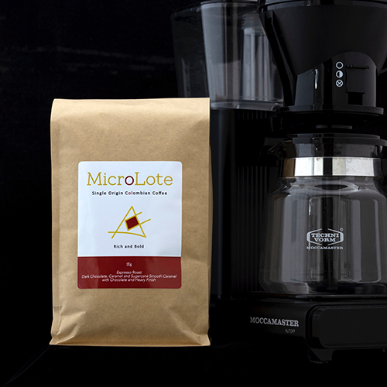
As an ALABC member, you and/or your company will receive the highest quality and freshest coffee possible. Not only will you be able to enjoy a great cup of coffee, but you'll also be able to share the story and the social impact of this project with your co-workers, family, and friends.
While traditional companies sell similar quality coffee for $45.00 to $60.00 per kg, with MICRO LOTE COFFEE, you can access the same quality for just $30.00 per kg, delivered right to your door.
To access this offer, simply visit our online shop and use the code ALABC at checkout.
By subscribing to MICRO LOTE COFFEE, you'll not only be enjoying delicious coffee, but also giving back to the 600 families who depend on small-scale coffee farming in Colombia. And in 2024, we plan to open this project for investors to benefit even more communities in Latin America.
For more information about our mission and impact, be sure to check out our Honest Coffee Documentary and Quinchía Coffee Project.
Join us in supporting small farmers and communities in Colombia by subscribing to MICRO LOTE COFFEE today.

